Assignment-1.4

NAME:

ZIAUDDIN

ROLLNO:

2403A51271

Task-1:

Install and configure GitHub Copilot in VS Code.

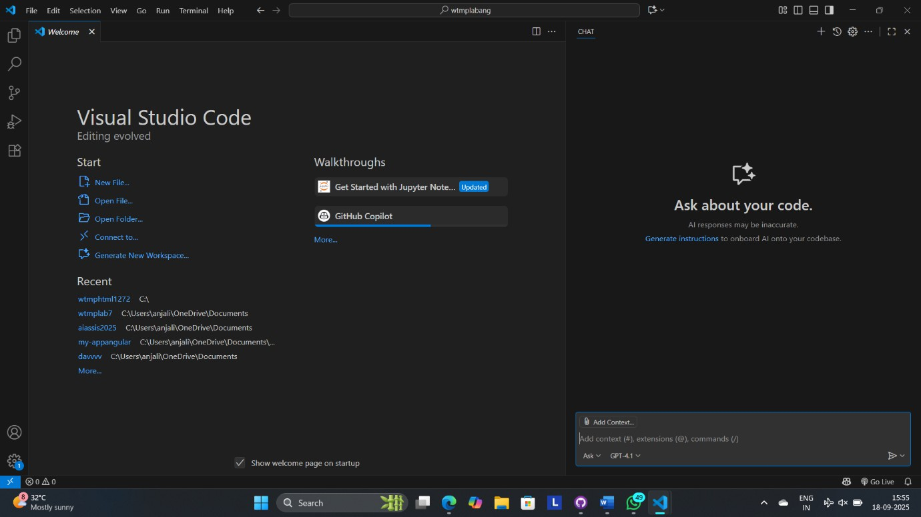

Task-2:

Prompt: Give a function in python that returns the maximum of three numbers that is entered by user.

Code:

def max_of_three():

a = float(input("Enter first number: "))

b = float(input("Enter second number: "))

c = float(input("Enter third number: ")) return max(a, b, c)

result = max_of_three()

print("The maximum number is:", result)

Output:

Enter first number: 10

Enter second number: 20 Enter third number: 5

The maximum number is: 20.0

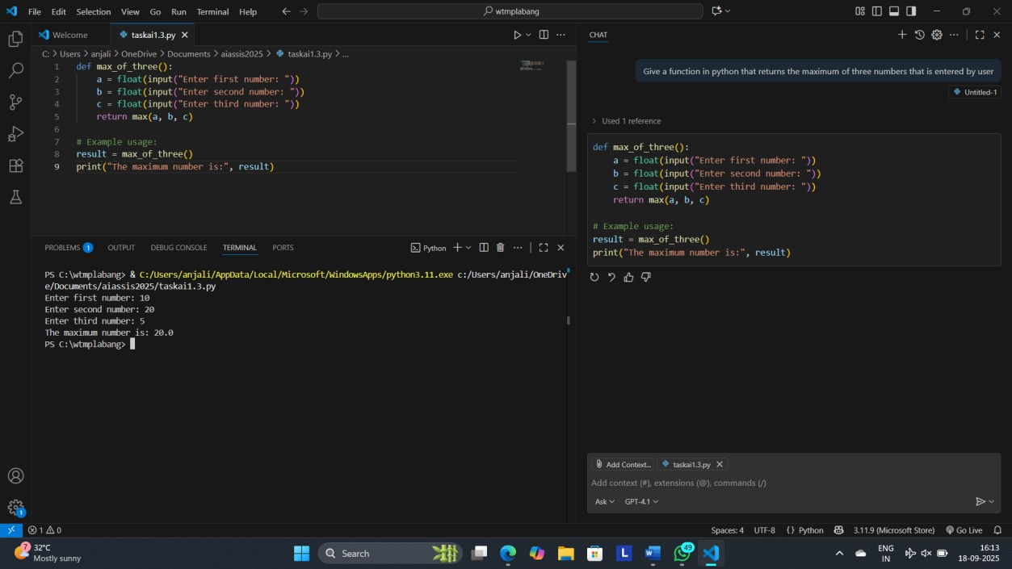

Task-3:

Prompt:

create a recursive Python function that calculates the factorial of a number entered by user.

Code:

def factorial(n):

if n == 0 or n == 1:

return 1 else:

return n * factorial(n - 1)

num = int(input("Enter a number to calculate its factorial: ")) print("The factorial of", num, "is:", factorial(num))

Output:

Enter a number to calculate its factorial: 5 The factorial of 5 is: 120

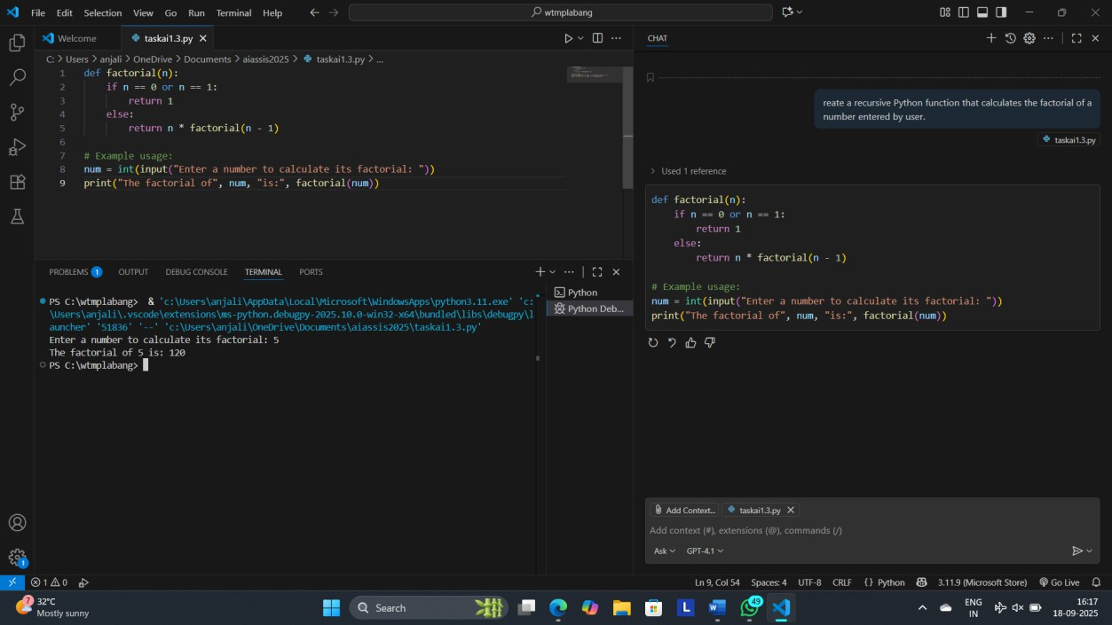

Task-4:

Prompt:

Create a class named Student with attributes name, roll_no, and marks. Add a method to display student details.

Code:

class Student:

def init (self, name, roll_no, marks): self.name = name

self.roll_no = roll_no self.marks = marks

def display_details(self):

print(f"Name: {self.name}")

print(f"Roll No: {self.roll_no}") print(f"Marks: {self.marks}")

student = Student("Alice", 101, 65)

student.display_details() Output:

Name: Alice Roll No: 101

Marks: 65

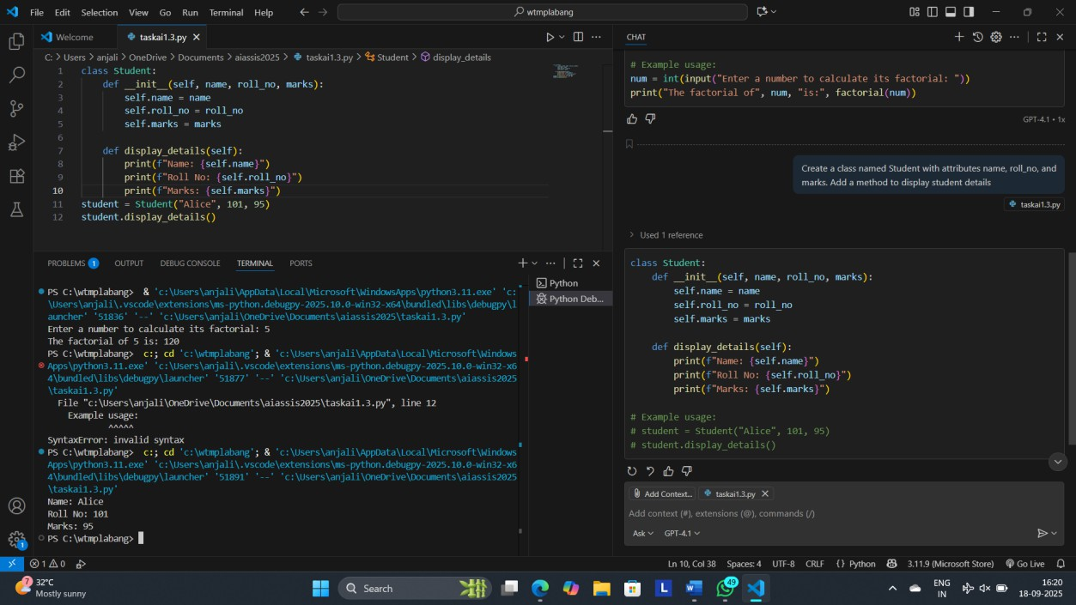

Task-5:

Prompt:

Generate a Python function that takes a string as input and returns the frequency of each word.

Code:

def word_frequency(text):

words = text.split() freq = {}

for word in words:

word = word.lower() # Optional: make it case-insensitive freq[word] = freq.get(word, 0) + 1

return freq

# Example input:

# text = "This is a test. This test is simple." # print(word_frequency(text))

Output:

{'this': 2, 'is': 2, 'a': 1, 'test.': 1, 'test': 1, 'simple.': 1}

